**Computational Neurodynamics**

Exercise Sheet 1 (Unassessed)

Numerical integration and neuron models

All the files for these exercises can be found online at

<https://github.com/pmediano/ComputationalNeurodynamics>

*Question 1.*

a) Start up a terminal and run the program EulerDemo.py. This should reproduce the plot on Slide 5 of Topic 3 (Numerical integration). Inspect the code and make sure you understand it.

b) The Euler method can also be applied to second-order ordinary differential equations. For example, a mass-spring-damper system can be described by the following second-order ODE:

where *m* is the mass, *c* is the damping coefficient, and *k* is the spring constant. Using the code in EulerDemo.py as a model, write a Python script to simulate a mass-spring-damper system using the Euler method. Initially let

If you let *m* = 1, *c* = 0.1, and *k* = 1, you should be able to get the following plot:

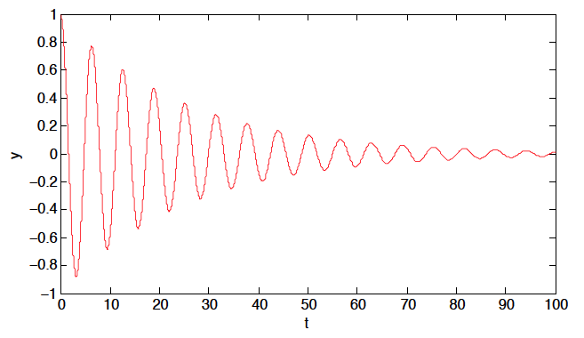

*Question 2.*

a) Run the script IzNeuronDemo.py. This should reproduce the plot of an excitatory Izhikevich neuron from the notes for Topic 4 (simple neuron models). Inspect the code and make sure you understand it.

b) Using the notes for Topic 4, adjust the parameters for the Izhikevich neuron so that they emulate an inhibitory neuron. Run the code again and verify that it reproduces the plot of an inhibitory Izhikevich neurons from the notes.

c) IzNeuronDemo.py uses the Euler method for numerical simulation. Reimplement it using the Runge-Kutta 4 method.

*Question 3.*

Using the equations and constants on the slides from Topic 2 (neurons), use the Euler method to simulate a single neuron using the Hodgkin-Huxley model. Verify that your code reproduces the plot of the Hodgkin-Huxley model in the notes, given a constant dendritic current of *I* = 10.

*Question 4* (for enthusiasts only).

Reimplement your code from Question 3 using the Runge-Kutta 4 method.